EXPERIMENT-2

Software Requirements Specification

For

ONLINE GLOBAL MARKETPLACE-OLX

Version 1.0

Prepared by GROUP 4

NORTHCAP UNIVERSITY

10TH OCTOBER 2019

Table of Contents

Table of Contents ii

Revision History ii

1. Introduction 1

1.1 Purpose 1

1.2 Document Conventions 1

1.3 Intended Audience and Reading Suggestions 1

1.4 Product Scope 1

1.5 References 1

2. Overall Description 2

2.1 Product Perspective 2

2.2 Product Functions 2

2.3 User Classes and Characteristics 2

2.4 Operating Environment 2

2.5 Design and Implementation Constraints 2

2.6 User Documentation 2

2.7 Assumptions and Dependencies 3

3. External Interface Requirements 3

3.1 User Interfaces 3

3.2 Hardware Interfaces 3

3.3 Software Interfaces 3

3.4 Communications Interfaces 3

4. System Features 4

4.1 System Feature 1 4

4.2 System Feature 2 (and so on) 4

5. Other Nonfunctional Requirements 4

5.1 Performance Requirements 4

5.2 Safety Requirements 5

5.3 Security Requirements 5

5.4 Software Quality Attributes 5

5.5 Business Rules 5

6. Other Requirements 5

Appendix A: Glossary 5

Appendix B: Analysis Models 5

Appendix C: To Be Determined List 6

# 1.Introduction

## Purpose

OLX.com – A website which will allow to electronically sell or buy goods. OLX.com, an online store to purchase or sell goods like mobiles, electronics, home appliances, cars and more. The purpose of this document is to build a user friendly online software system for customers and sellers who can buy or sell their products on OLX. This document describes the target audience and its user interface and will help OLX in revenue generation. Payment options available on the website – COD, EMI, Credit card, Debit card etc.

## Document Conventions

This document uses following conventions

|  |  |
| --- | --- |
| DB | Data Base |
| DDB | Distributed Data Base |
| OSS | Online Shopping System |
| SRS | Software Requirement Specification |
| GUI | Graphic User Interface |
| Stack-Holder | The person who will participate in the system e.g. Customer, Supplier, Administrator |
| Modem | Modulator-demodulator, a devise that modulates an analog carrier signal to encode digital information, and also demodulates such a carrier signal to decode the transmitted information |
| Ethernet | A family of frame – based computer networking technology works |
| MLA | Modern Language Association |
| CSS | Cascading Style Sheet |

## Intended Audience and Reading Suggestions

This project is a prototype for the OLX Company and it is restricted for use by company employees, customers and suppliers. This has been implemented under the guidance of the software provider. This project is useful for the employees, customers and suppliers to the OLX.

## Product Scope

The purpose of the online marketplace management system is to ease customers and supplies to interact with OLX. The interaction between different stakeholders will be through transfer of information across the internet. It will create a convenient and easy-to-use application for the OLX employees, customers and the suppliers.

## References

1. <https://www.w3schools.com/>
2. <https://en.wikipedia.org/wiki/Online_marketplace>

# Overall Description

## Product Perspective

Larger online marketplaces such as eBay and Craigslist had extensive operations across developed markets but had shown little interest in establishing a presence in emerging markets, particularly across Latin American, Eastern Europe, and South East Asia.Therefore,easier accessibility and innovation of such services is required in a new online marketplace OLX.The mission is to improve lives by providing local communities a vibrant online market where people can connect with each other. On the OLX platforms, people can buy and sell used goods, services, cars and properties.

## Product Functions

* Allow customer to **register** a user account
* **Sell** a range of products, including electronics, clothes, furniture, cars, and home appliances:-
* Create ad
* Select the **category** and sub-category of the product you want to sell
* Give essential information about the product such as name, description, and images.
* Provide contact number..
* Publish your advertisement
* Buyer can **Browse** classified ads by category, place,advertisements and then contact seller through
* Phone call
* Message,chat with buyer option

••

The major features of OLX are as shown below:-

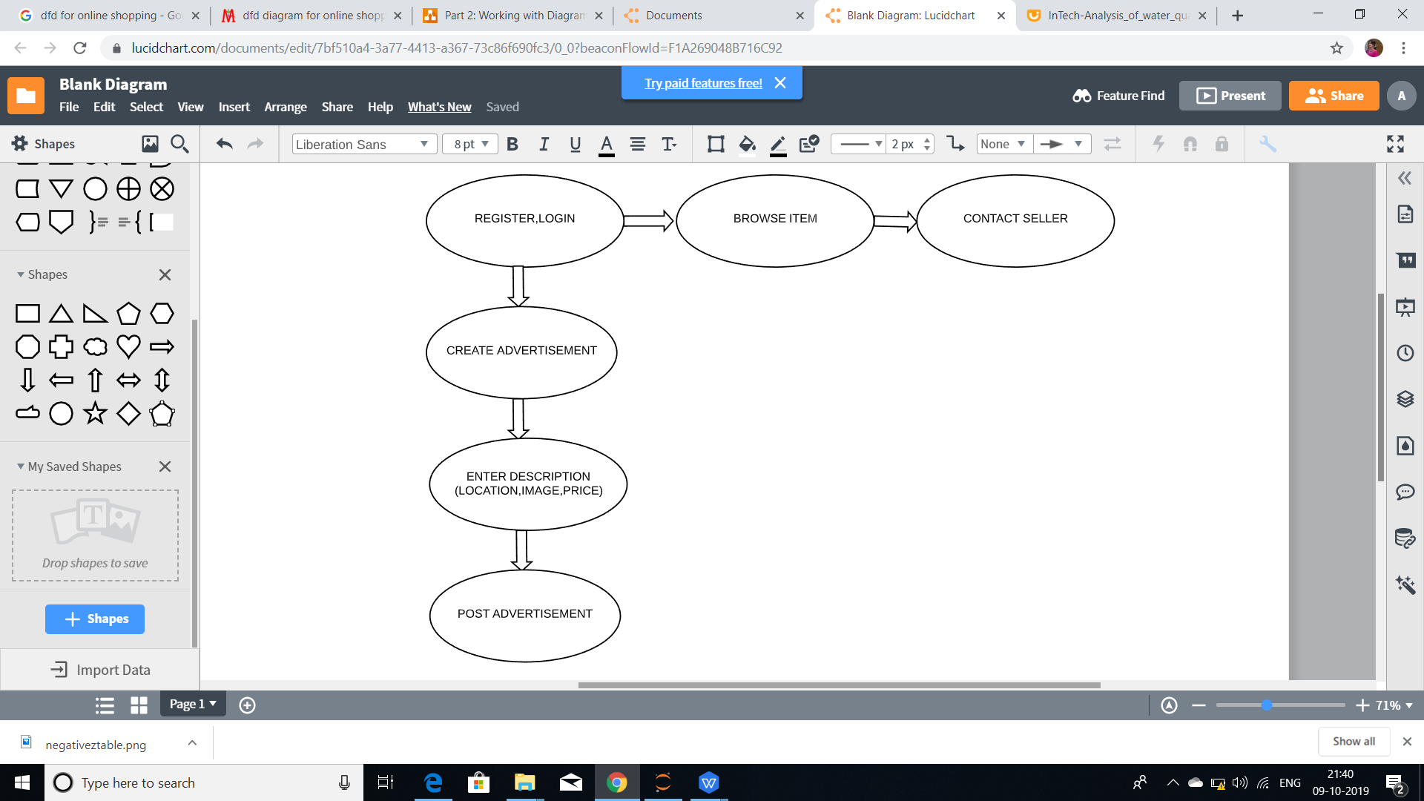

## User Classes and Characteristics

1. UserInfo
2. SearchItem
3. ItemDescription
4. PublishAdv

CLASS UserInfo contains name,DOB,location of user

**For Sellers**: Class PublishAdv

Seller will take the pictures of his product and then choose a category for posting his product price and description.

**For Buyers:** Class SearchItem

Buyer gives location and choose category and search in a search bar by using product name and can also give brand name and mention price filters. And then select a desirable product and contact with the seller by his number and message inbox.

## Operating Environment

Operating environment for the OLX is as listed below:-

* Distributed database
* Client/server system
* Operating system: Supports all known operating systems, such as Windows, Linux

Software is designed to run on any platform including IOS , android , windows , linux .

* Database: **NoSQL** (mongoDB)
* Platform: vb.net/Java/PHP
* Classified website (www.OLX.com) and works on C2C (Consumer to Consumer) business model.
  1. **Design and implementation constraints**

### Standard Development Tools

The system shall be built using a standard web page development tool that conforms to either Android and ios standards or Microsoft’s GUI standards.

### Web Based Product

There are no memory requirements

  The computers must be equipped with web browsers such as Internet explorer.

  The product must be stored in such a way that allows the client easy access to it.

  Response time for loading the product should take no longer than one minute.

  A general knowledge of basic computer skills or mobile skills is required to use the product

## On-line User Documentation and Help System Requirements

As the product is E-store, On-line help system becomes a critical component of the system which shall provide –

It shall provide specific guidelines to a user for using the E-Store system and within the system.

To implement online user help, link and search fields shall be provided.

Online help tutorials and user manuals will be provided with the software.

**3. External Interface Requirements**

**3.1 User interface**

**3.1.1 Login interface**

This interface consist of two important components “**username**” and “**verification password**”. There will be option for “new user registration” which will lead to home page and one more option is there for “forget password”. If password is correct main interface opens up else error is shown.

**3.1.2 Customer interface**

Home screen offers the menu with list of functions that site performs. It allows customer to buy or sell product.

**3.2 Hardware Interface**

The system must run over the internet, all hardware that requires internet connection will be hardware interface for the system. E.g. modem, WAN-LAN, Ethernet cross cable.

**3.3 Software Interface**

This software is compatible for windows, mac, Linux and android. The system is on server so it requires any scripting language like PHP, VBScript etc. The system requires database management (like MYSQL) to store any transaction of the system like

**3.4 Communication Interface**

This system supports all type of web browsers. Once deal is done between buyer and seller both will get relevant message in their email.

# System Features

* Simple layout and easy to understand instructions.
* Easily designed and customizable rich colorful ads with pictures and videos. App allows posting interactive ads with photos and videos. The photos and videos of your product can attract buyers and give them a clear idea about the product. It is absolutely free. You can buy things online or directly from the sellers.
* Ability to control your buying, selling and community activity in ‘My OLX’ section.
* Display your ads on your social networking profile (Facebook, Myspace, Orkut etc.).
* Ability to access the website in your local language.
* The items are categorized and can be accessed easily.
* Mobile friendly site. You can access the site from your mobile phone. It has a mobile optimized website for faster access.
* In India, It is available in many local languages.
* Customized site for almost all cities.
* You can buy or sell things from more than 96 countries all over world.

**5. NONFUNCTIONAL REQUIREMENTS**

Non-functional requirements define system properties and constraints

Following Non-Functional requirements will be there in the insurance to the internet:

* Secure access to customer’s confidential data.
* 24X7 availability
* Better component design to get better performance at peak time
* Flexible service based architecture will be highly desirable for future extension.

**5.1 PERFORMANCE REQUIREMENTS**

Performance requirements define acceptable response times for system functionality. Although the system is developed suiting for the least system performances, the performance of the system will highly depend on the performance of the hardware and software components of the installing computer. When consider about the timing relationships of the system the load time for user interface screens shall take no longer than two seconds. It makes fast access to system functions. The log in information shall be verified within five seconds causes’ efficiency of the system. Returning query results within five seconds makes search function more accurate.

1. **E-R DIAGRAM:**

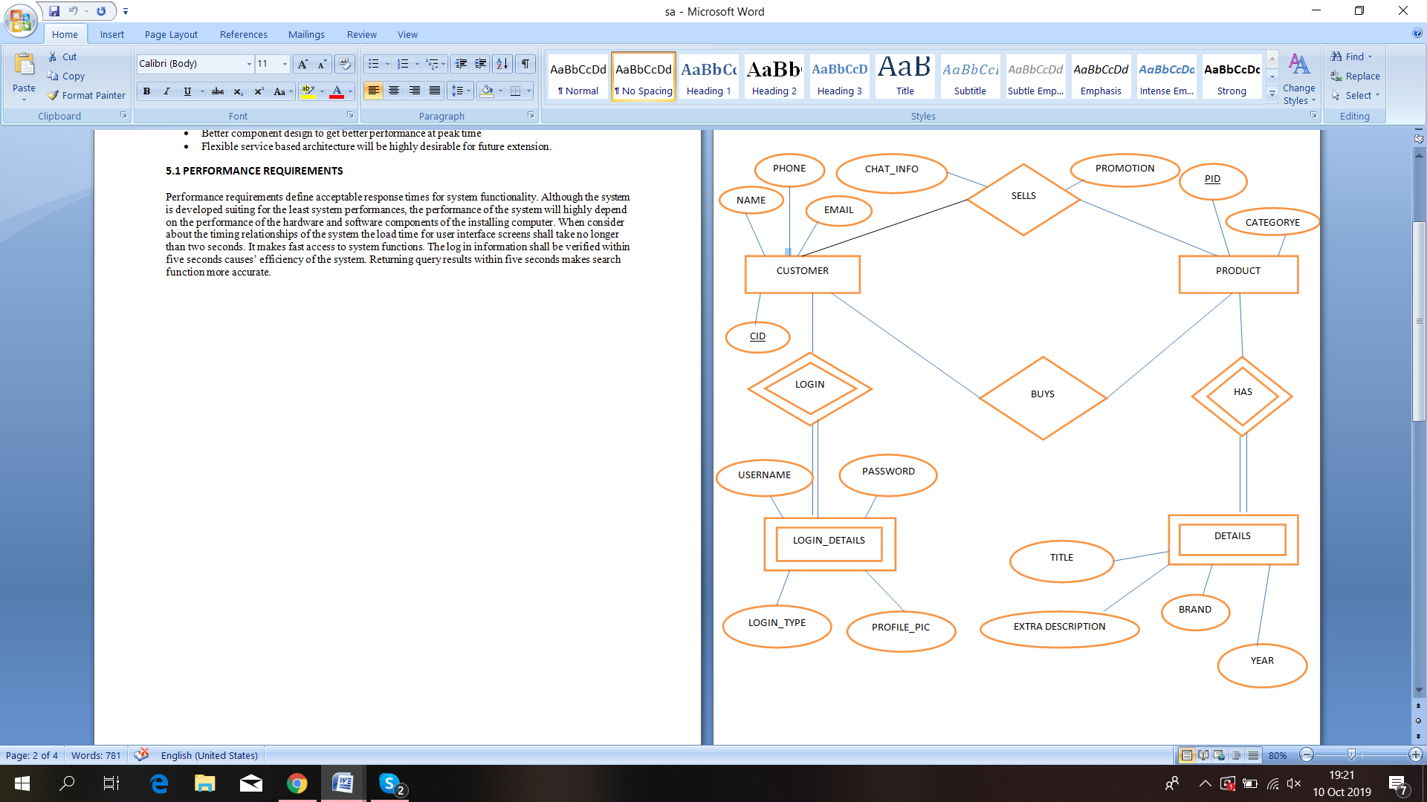

**5.2 SAFETY REQUIREMENTS**

There are several user levels in online global marketplace. Access to the various subsystems will be protected by a user log in screen that requires a user name and password. This gives different views and accessible functions of user levels through the system. Maintaining backups ensure the system database security. System can be restoring in any case of emergency.

**5.3 Security Requirements**

Customer Service Representatives and Managers and owner will be able to log in to online application. Customer Service Representatives will have access to the Selling or purchasing subsystems. Managers will have access to the Management subsystem as well as the selling and buying subsystems. Access to the various subsystems will be protected by a user log in screen that requires a user name and password.

**5.4 TECHNICAL ISSUES**The system will work on client-server architecture. It will require an internet server. Customer will be able to log in to site only if he/she has internet connection. The system supports browser such as Mozilla Firefox, Chrome.

**5.5 PRIVACY AND SECURITY**

Customer plays an important role and hence securing their information is highly needed. For this reason, we do not directly process payment details and do not store credit card information. However, their registration information is protected by a unique customer password and user ID. The user should not disclose his/her password to anyone and should always remember to log out his/her account if using a shared computer. Also, the user can utilize the website as an anonymous user by not registering.

**5.6 Software Quality Attributes**

* Availability: - The system shall be available during normal item operating hours
* Correctness: - extent to which program satisfies specifications, fulfil user’s mission objectives
* Efficiency: - How much less number of resources and time are required to achieve a particular task through the system.
* Flexibility: - Ability to add new features to the system and handle them conveniently.
* Integrity: - How the system would insecure the information in the system and how it avoids the data losses. Referential integrity in database tables and interfaces
* Maintainability: - How easy is to keep the system as it is and correct defects with making changes.
* Portability: - The online global marketplace application shall run in any Microsoft Windows environment
* Reliability: - Specify the factors required to establish the required reliability of the software system at time of delivery. Mean time between failures and mean time to recovery
* Reusability: - What is the ability to use the available components of the system in other systems as well.
* Testability: - Effort needed to test to ensure performs as intended
* Usability: - How easily a person can be taken the benefits of the system and the user friendliness.
* Robustness: – Strength of the system to handle system functions accurately and maintain the database without facing to unexpected failures
* Maintainability: – What design, coding standards must be adhered to exclusions created

**6. Other Requirements**

When the system is completely developed and submitted to the client, few sessions will be required to make the users of the system understand about the functionality of it and some time to adapt to the system. After those sessions, it’s required that a member from the development team should spend sometime in the system background for an agreed time period. That time period will be used in identifying new bugs that could not be reached in the earlier phases of the development process.

Client should have a valid e-mail account in order to receive reservation e-mail notifications.

**Appendix:**

*User Manual on OLX*